Physical & Health Education BINGO (0409) (Online)
Do as many items on this BINGO card as you can.
You choose if these are daily activities or to be accomplished during the week. Whatever you choose to do, give yourself a positive affirmation for your participation!
Please use this copy digitally :)

Check out Joe Wicks’ website. He’s giving daily online P.E. classes for kids!  (1st Day is: Monday 23rd March 2020)  https://www.youtube.com/watch?v=Rz0go1pTda8 | Watch kids from around the world practice good handwashing.  https://www.youtube.com/watch?v=_02FuyeCWFU  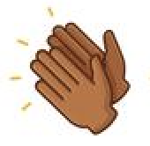 | Find a space to practice this warm up move. It’s called “Carioca” (care-e-o-key).  https://www.youtube.com/watch?v=ZR5RGRSl4rM
A classic dance move!!!!  (if you want, fast forward to 0:48 seconds)  https://www.youtube.com/watch?v=n5FXpc1nPr0  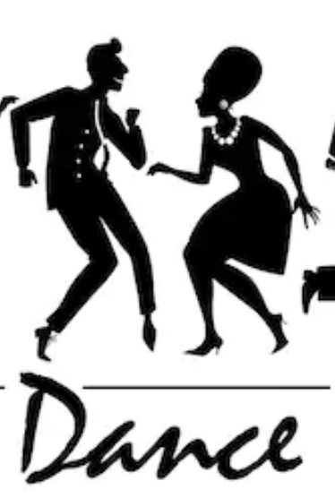 | Remember, you are not alone during this time. Others, somewhere in their home, are dancing too!  https://www.youtube.com/watch?v=95yh8eDT4Iw | Workout with the YMCA. (suitable for any age)  https://www.youtube.com/watch?v=bbfu-ZEs4fg  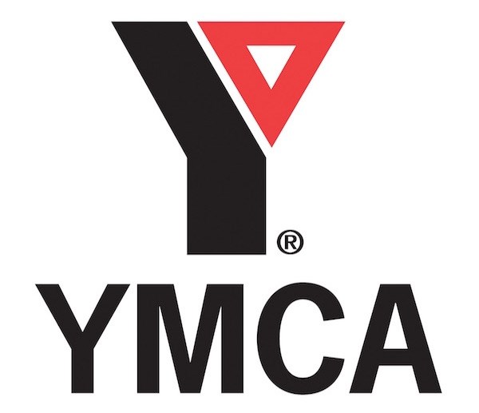
Need to move a little slowly, try this song “One Love” sung by the Neville Brothers.  https://www.youtube.com/watch?v=CiFdsngTviQ | Drink one more glass of water each day.  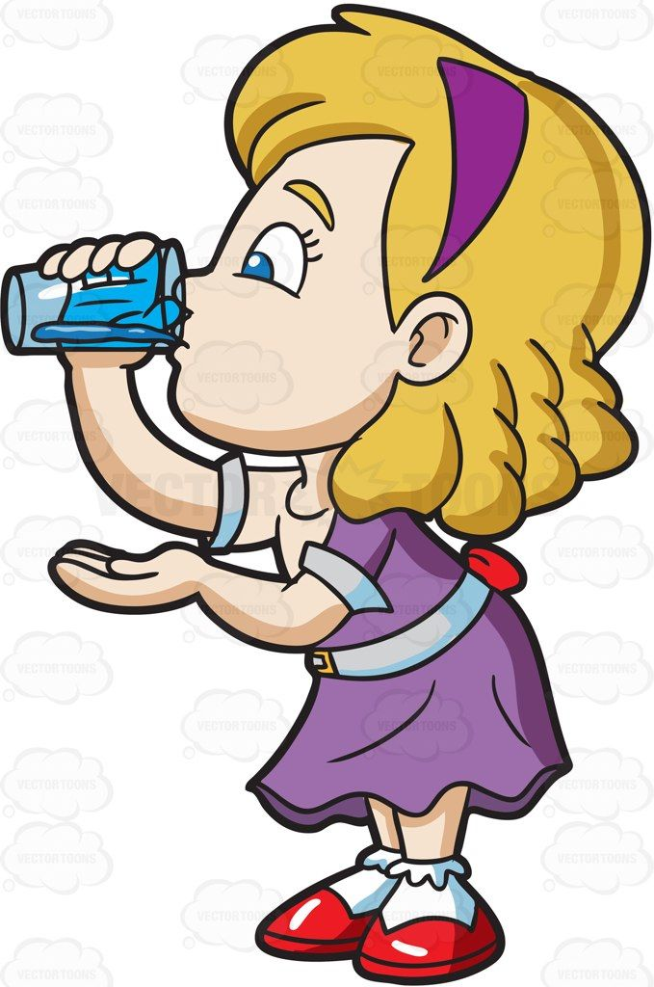 | 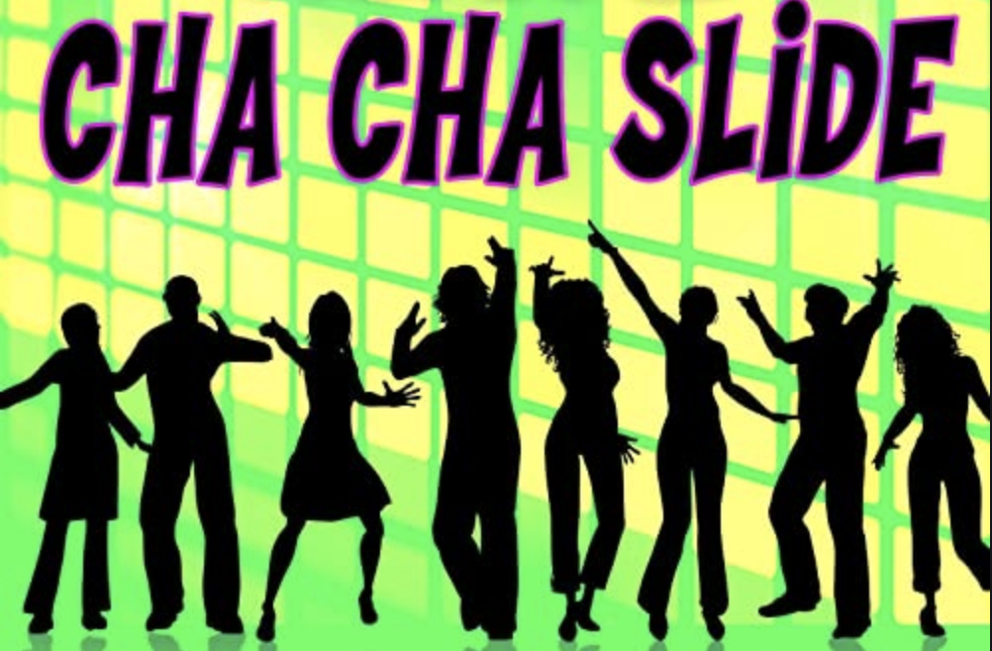  https://www.youtube.com/watch?v=gpQTmp4A2Kw

