Music - Notation

Duration of a note; how long does a note play for

When we see music notes we need to know how long to sing or play that note.

“The note is sung or played for how long?”
“We hear the note being played for how many beats?”

This quarter note is worth one beat. You hear it for one beat in length.

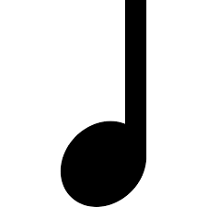

Quarter notes are also called ‘ta’.

~~ ~~

Eighth notes are worth one beat. Yes, you play it twice, however it is played within the timeframe of one beat.
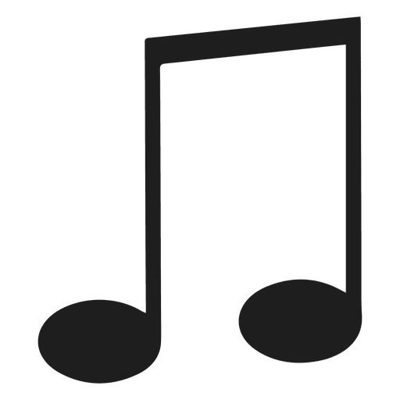

Eighth notes are also called ‘titi’ or ‘ti-ti’.

~~ ~~

Half notes are worth two beats. “We let the note be heard for 2 beats!”
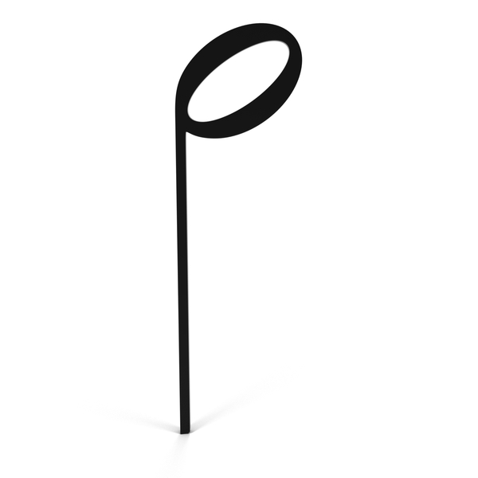

Half notes are also called ‘two-oo’.

~~ ~~

Dotted half notes are also called ‘three-ee-ee’. And this note is heard for three beats.

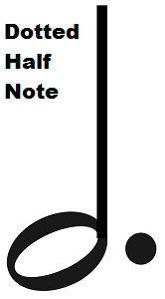

~~ ~~

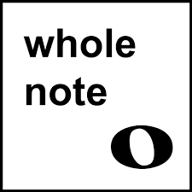

Whole notes are also called ‘fo-o-o-ur’. And we hear this note for four beats.

Example:

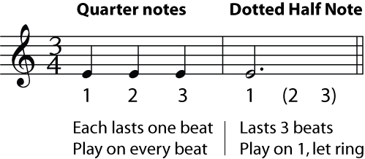

Notation: Value of a Note and a Rest

A rest is when there is a break in the playing of instruments or a singing voice. Therefore we do not hear the instrument during a rest (it’s tired, it’s taking a rest!)

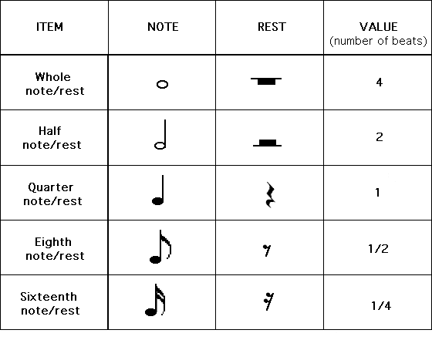

Or maybe you like this chart best:

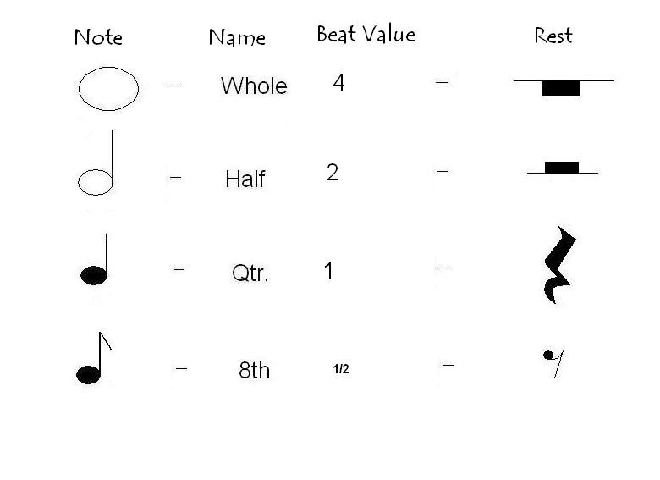

Here is another way to look at the value of musical notes:

